vivado2015.3的安装

1、登陆网址http://www.xilinx.com/

2、DEVELOPER ZONE/Vivado Design Suite-HLx Editions

3、选择30-day Vivado Design Suite Evaluation

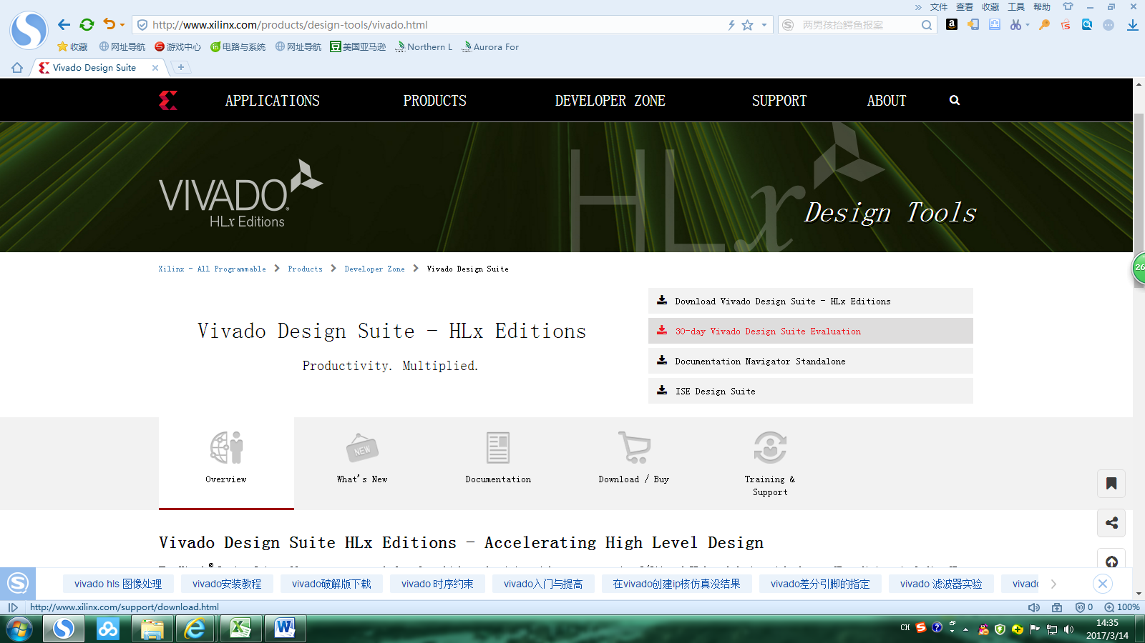

4、选择2015.3版本，进入页面后选择 [Vivado 2015.3 WebInstall for Windows with SDK](http://www.xilinx.com/member/forms/download/xef.html?filename=Xilinx_Vivado_SDK_2015.3_0929_1_Win64.exe&akdm=0) (EXE - 48.97 MB)或者 [Vivado 2015.3: Full Installer For Windows Single File Download Image Including SDK](http://www.xilinx.com/member/forms/download/xef.html?filename=Xilinx_Vivado_SDK_Win_2015.3_0929_1.tar.gz&akdm=1) (TAR/GZIP - 7.11 GB)都可以

5、点击后弹出登陆页面，可选择[Create your account](https://www.xilinx.com/registration/create-account.html)进入注册页面填写注册信息，注意必须注册并登陆后才能在该网站下载软件

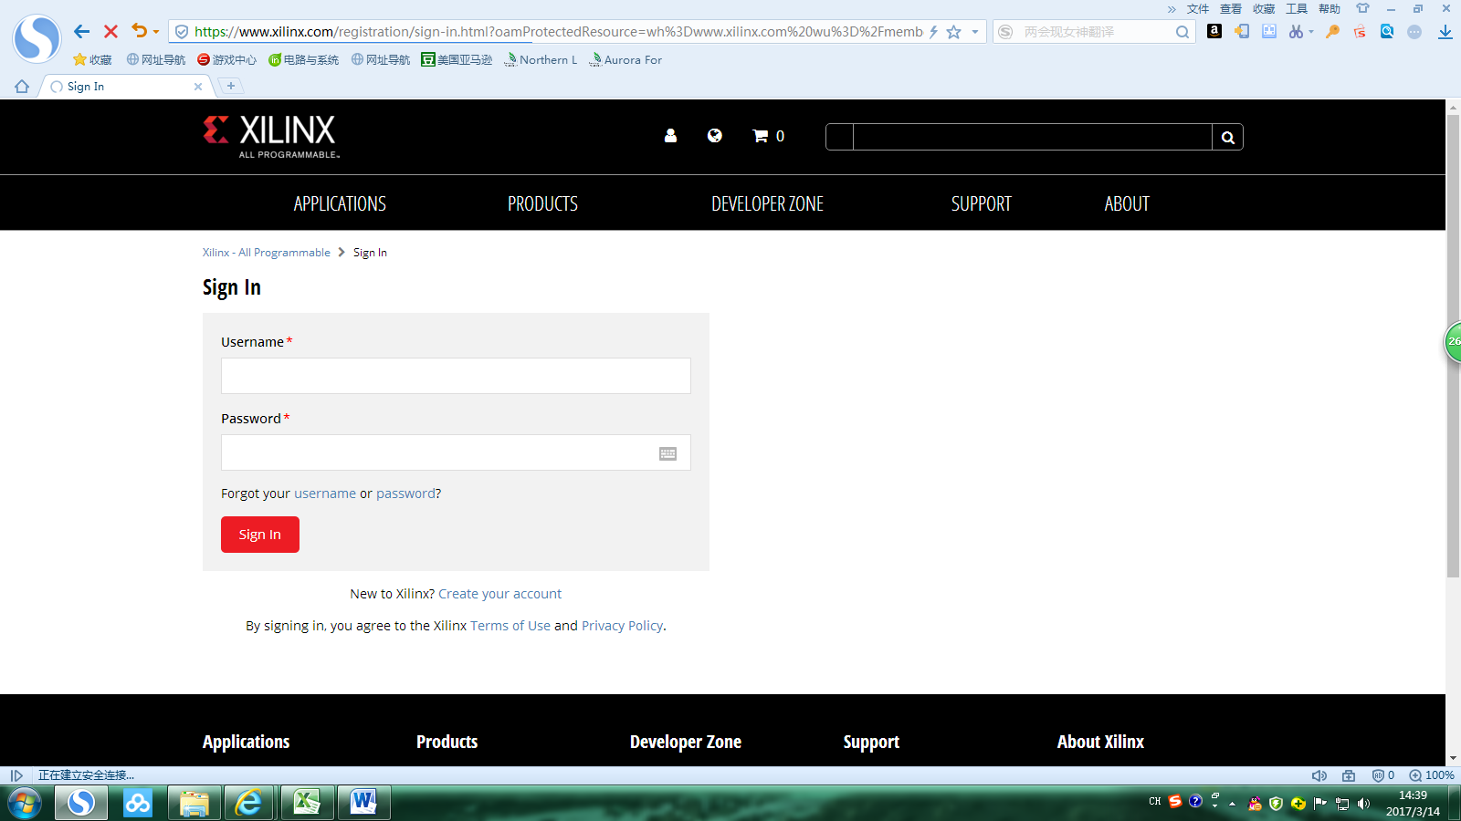

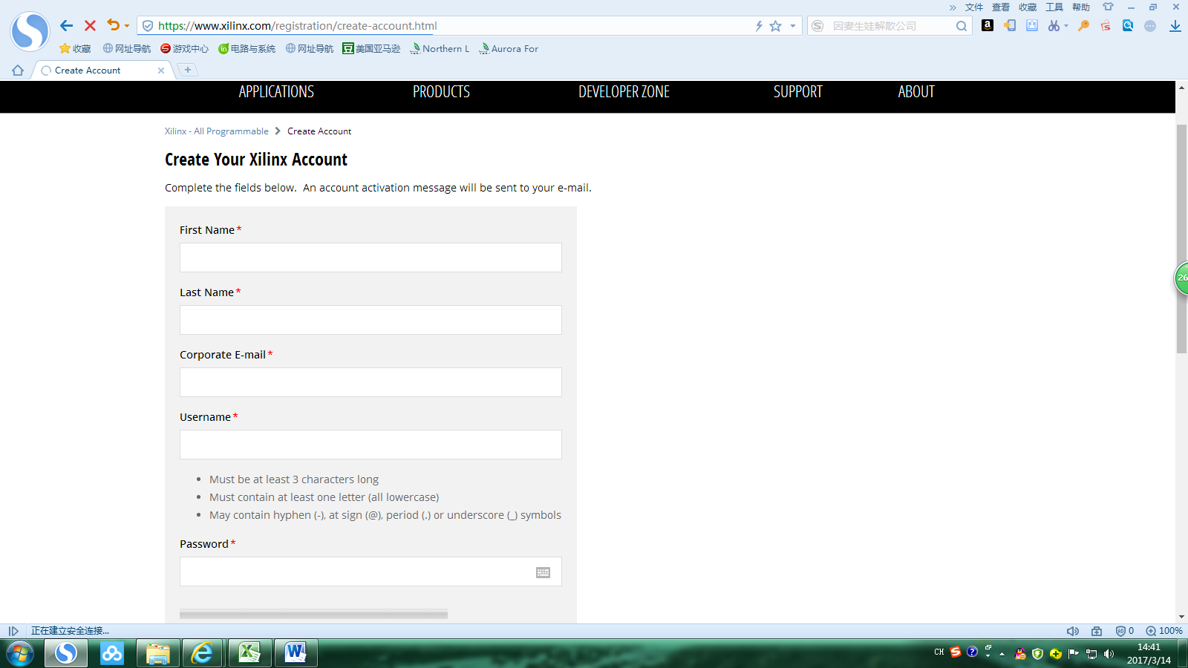

6、接下来点击下一步进入下载，安装按照默认设置。license选择如下

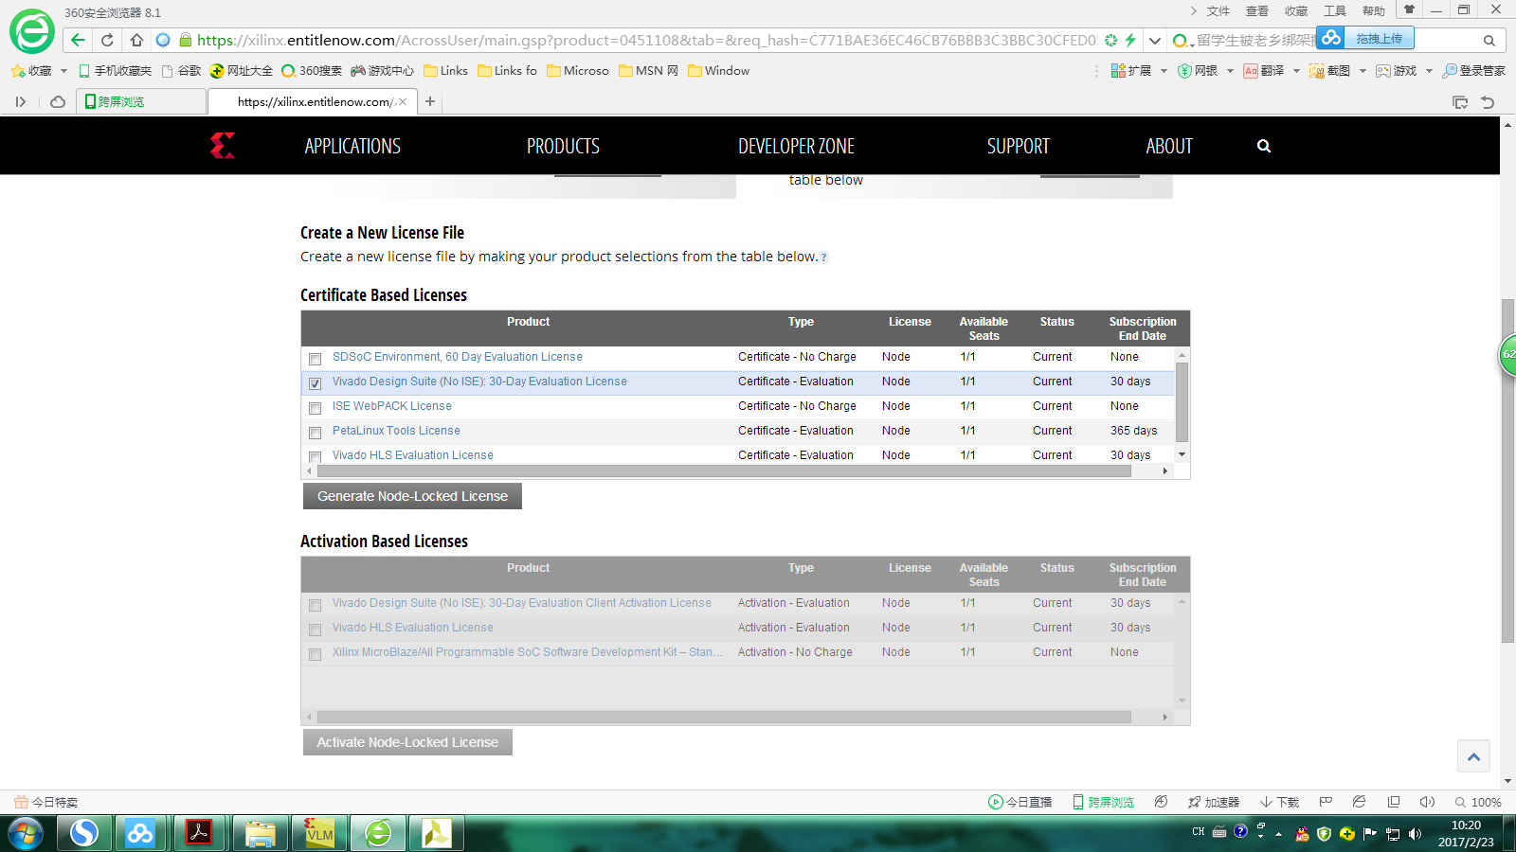

system information: host ID 选择本机网卡物理地址

